CSR Creation Instructions for Renewing Expiring/ Expired Certificates

(PROD Environment)

Overview
Step 1: Vendor generates the CSR using the instructions below
Step 2: Once the CSR is received, Conexus Support will complete the request and send the vendor the generated web services certificate.
Step 3: Vendor installs new certificate, removed expiring or expired certificate.
Step 4: Vendor uses endpoints to test connectivity.

Introduction
This document provides instructions for generating a Certificate Signing Request (CSR) using OpenSSL. The CSR is used to generate an SSL certificate. This is an important requirement for the Conexus integration. While there are many tools and platforms used to generate a CSR, this document will illustrate the steps using OpenSSL. If you are using a different tool to generate a CSR, your steps may be slightly different, but it does not change how the key fields are filled out.
Please note this is for PROD environment only.

Generating the CSR
This section describes the process to create a CSR. Perform the following:
- Ensure you can execute OpenSSL.
- To generate the CSR, run the following from the command line:
openssl req -out conexus_ContractorOrganization.csr -new -newkey rsa:2048 -nodes -keyout privatekey.key
NOTE: The private key should remain in your possession and should never be given to anyone else. Please do not send the private key to Conexus.
You will be prompted to enter the following information:
  - In the Common Name field, enter the <SP GUID>
    - This globally unique ID string will be included in the renewal request email submitted via Conexus.System@gsa.gov
For example: CN = C9CD22B31C184BBEZE6544075FF46203
  - In the Organizational Unit field, type ICAM <– THIS EXACT VALUE IS REQUIRED
  - In the Organization field, type USDA <– THIS EXACT VALUE IS REQUIRED
  - In the Locality Name field, enter the city where your organization is legally located.
  - In the State or Province Name field, enter the state or province where your organization is legally located. Do not use abbreviation.
  - In the Country Name field, enter the two-letter ISO abbreviation for the country in which the system resides.
- Check and verify CSR:
openssl req -text -noout -verify -in conexus_ContractorOrganization.csr
NOTE: Ensure the SP GUID you received from Conexus shows here.
Figure 1. Sample output

verify OK
Certificate Request:
Data:
Version: 0 (0x0)
Subject: OU=acme, CN=C9CD22B31C184BBEZE6544075FF46203
Subject Public Key Info:
Public Key Algorithm: rsaEncryption
Public-Key: (2048 bit)
Modulus:
00:bd:76:4d:7e:a5:8d:00:0a:2e:62:8a:2a:dd:27:
74:bc:f2:ec:9f:cf:94:21:35:f2:5b:16:fd:fa:35:
0f:26:d1:8a:4d:c2:2c:63:ff:b1:0d:24:ef:2b:75:
03:7d:d0:43:49:8a:18:60:ec:97:5b:19:4f:27:bb:
c3:12:a0:a4:0a:bc:27:dc:15:57:97:4b:c3:fb:2c:
e3:05:bc:6e:41:c0:1d:56:5a:37:43:3e:b2:22:74:
9a:78:4a:ae:03:21:9a:4b:b7:cf:88:ef:de:0b:cc:
c3:69:e6:e1:b2:f2:09:b4:a1:cb:a5:8d:e3:cc:bf:
6d:f1:c3:38:27:fc:2c:12:74:e9:53:89:2d:14:a1:
09:a6:7a:71:07:1a:89:7d:10:c5:09:14:bf:2f:0d:
f8:c1:0f:c8:61:cf:da:de:d5:8b:fb:17:7d:1d:4d:
87:ee:f8:0b:3d:8e:23:fc:54:e6:e7:c4:e2:27:7a:
61:0f:0a:b4:19:70:c5:b6:30:f2:c0:7f:6c:0c:12:
22:2f:5f:b0:05:44:2a:ea:97:a9:64:66:9f:31:24:
74:03:22:ab:a4:77:af:c4:2e:d4:bd:31:03:5f:19:
27:2e:70:22:de:ce:d0:aa:61:55:14:27:8d:39:fa:
16:a4:63:83:30:dc:2c:86:f6:46:e8:bf:71:5f:00:
1c:af
Exponent: 65537 (0x10001)
Attributes:
a0:00
Signature Algorithm: sha256WithRSAEncryption
2d:c8:be:f1:fe:71:d0:32:f2:cc:65:e6:e5:c9:50:47:3b:74:
28:e5:b4:f7:78:eb:04:34:3c:c1:0e:5a:1f:38:71:37:3a:1e:
90:9f:07:df:a5:af:3a:18:80:b2:ae:dd:75:83:01:bc:e0:ba:
4f:14:10:60:38:1c:e9:be:8a:74:36:84:b7:37:ca:87:e3:72:
15:dc:af:96:4d:9a:39:3c:52:65:57:e7:d0:b9:39:31:b5:47:
b9:d8:4b:8c:c5:83:ba:16:bb:fa:6b:16:06:1b:82:8e:af:77:
d9:a7:2a:d1:f4:12:e3:6c:d3:3c:b1:7a:53:a4:3b:80:dd:26:
f3:72:90:5b:08:96:a5:c6:4b:97:a5:07:81:c3:5f:05:fa:0c:
c9:1f:75:33:0b:04:f1:84:94:9d:9e:3f:b8:6a:6a:21:2a:5d:
2a:c4:5f:65:3e:9e:75:22:9b:a0:22:00:43:5e:63:d3:40:58:
c0:93:e8:74:34:a5:04:98:3a:97:4b:46:7e:12:d6:50:f7:76:
a0:45:73:15:d8:18:e8:a6:66:92:41:01:c3:b2:23:5c:7b:c1:
78:99:7d:4e:db:01:ff:fa:85:66:18:df:6c:24:9a:e5:23:53:
c8:bb:57:4e:7b:8b:0a:aa:a8:84:c2:20:a3:42:2c:74:68:2f:
c2:5a:49:bd
- Send the CSR to Conexus.System@gsa.gov.
Note: The private key should remain in your possession and should never be given to anyone else. Please do not send the private key back to Conexus.System@gsa.gov or it will be rejected.
- Once you receive the certificate from Conexus.System@gsa.gov, deploy the private key and the certificate on the system that is executing the requests.

Additional Validation
You can perform the following steps to ensure your CSR will be accepted:
- Open the CSR in a text editor
- Copy the complete text to your clipboard
- Go to http://www.entrust.net/ssl-technical/csr-viewer.cfm
- Paste the CSR text into the text box
Review the values as shown in the screenshot below:
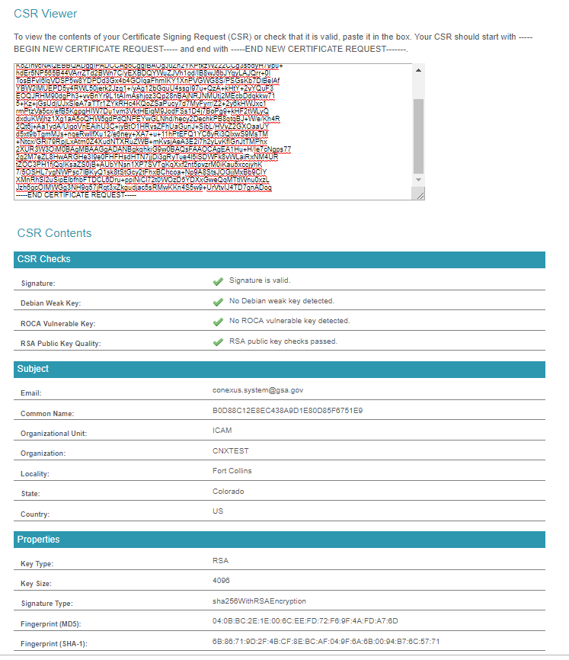
This field should say exactly “USDA”

This field should say exactly “ICAM”

Email should contain the service account address for the vendor

The city and state or province where your organization is legally located. Do not use abbreviations

  - J.Doe@VendorName.com

  - SPGUID PROVIDED BY CONEXUS

  - USDA

  - ICAM

This field must say exactly “RSA”

This field must be at least 2048. 4096 or greater is permitted

  - This field should match the SPGUID

  - The Signature and Debian Weak Key should have green checkmarks

  - The Signature and Debian Weak Key should have green checkmarks
  - Email should be complete and contain the service account address for the vendor
  - Common Name should be the SPGUID provided by Conexus
  - Organizational Unit should say exactly - ICAM
  - Organization should say exactly - USDA
  - Key Type should be RSA
  - Key Size should be at least 2048. Greater is allowed, but less than that (i.e. 1024) is considered too weak
If any of these values are incorrect, the CSR will be rejected and will have to be re-created.

Conexus Support Guidelines
The Conexus support team will provide assistance with connectivity under the following conditions:
- We will assist with connectivity troubleshooting on one device
  - That device must be the device from which the CSR was generated and on which the certificate is installed
- When requesting troubleshooting assistance, provide the following:
  - Execute the following commands:
openssl x509 -noout -modulus -in certificate.crt | openssl md5
openssl rsa -noout -modulus -in privateKey.key | openssl md5
Replacing certificate.crt and privateKey.key with the relevant file names.
What we cannot do:
- We cannot generate the CSR on your behalf
- We cannot modify or manipulate the CSR or resulting certificate
We are unable to provide support for any configuration outside the boundaries described above.

Valid Endpoints for Testing in CERT Environment
The following endpoints are valid URLs that can be used to test connectivity to Conexus web services in Certification Environment.
- https://api.cert.eauth.usda.gov/eas/conexus/dbas
- https://api.cert.eauth.usda.gov/eas/conexus/soa
- https://api.cert.eauth.usda.gov/eas/conexus/soc
- https://api.cert.eauth.usda.gov/eas/conexus/sorn
- https://api.cert.eauth.usda.gov/eas/conexus/focn
- https://api.cert.eauth.usda.gov/eas/conexus/socn
- https://api.cert.eauth.usda.gov/eas/conexus/sscn
- https://api.cert.eauth.usda.gov/eas/conexus/soac

Frequently Asked Questions
Q: How do I know if I am sending a valid CSR?
A: You can verify the information when you execute the command in step #3 in the instructions.
Q: How long will it take to get my certificate?
A: This process takes 3-5 business days from the day you send the CSR to Conexus.System@gsa.gov .
Q: Where do I install my certificate?
A: The certificate must be installed on the system that will execute the web services request.
Q: What if my certificate does not work?
A: Ensure that all the settings and configurations in your environment are set up correctly. Send an email to Conexus.System@gsa.gov with all the steps you have taken and a screen shot of any errors captured.
Q: Where is my private key?
A: The private key should reside in your environment.
Q: Why do I need a private key?
A: The private key is used to authenticate your server to our server.
Q: What URLs should I use to test connectivity?
A: Please see the section Valid Endpoints for Testing
Q: How do I check to make sure the certificate and private key match?
A: Execute the following commands:
openssl x509 -noout -modulus -in certificate.crt | openssl md5
openssl rsa -noout -modulus -in privateKey.key | openssl md5
Replacing certificate.crt and privateKey.key with the relevant file names. The values returned should match.

